**Day 23 - BST - Level Order Traversal**

<https://www.hackerrank.com/challenges/30-binary-trees/problem>

**Objective**  
Today, we're going further with Binary Search Trees. Check out the [Tutorial](https://www.hackerrank.com/challenges/30-binary-trees/tutorial) tab for learning materials and an instructional video!

**Task**  
A level-order traversal, also known as a breadth-first search, visits each level of a tree's nodes from left to right, top to bottom. You are given a pointer, root, pointing to the root of a binary search tree. Complete the levelOrder function provided in your editor so that it prints the level-order traversal of the binary search tree.

**Hint:** You'll find a queue helpful in completing this challenge.

**Function Description**

Complete the levelOrder function in the editor below.

levelOrder has the following parameter:  
- Node pointer root: a reference to the root of the tree

**Prints**  
- Print node.data items as space-separated line of integers. No return value is expected.

**Input Format**

The locked stub code in your editor reads the following inputs and assembles them into a BST:  
The first line contains an integer, T (the number of test cases).  
The T subsequent lines each contain an integer, data, denoting the value of an element that must be added to the BST.

**Constraints**

* 1 <= N <= 20
* 1 <= node.data[i] <= 100

**Output Format**

Print the data value of each node in the tree's level-order traversal as a single line of N space-separated integers.

**Sample Input**

6

3

5

4

7

2

1

**Sample Output**

3 2 5 1 4 7

**Explanation**

The input forms the following binary search tree:  
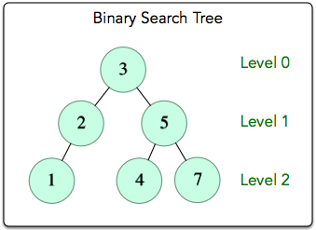

We traverse each level of the tree from the root downward, and we process the nodes at each level from left to right. The resulting level-order traversal is 3 -> 2 -> 5 -> 1 -> 4 -> 7, and we print these data values as a single line of space-separated integers.